DATE: January 31, 2022

TO: Dr. Emin Kececi

FROM: UltraVisor-C Team

SUBJECT: Clarifying UltraVisor-C Team Goals

**Addressing the Problem and the Need for UltraVisor-C**

The current pandemic poses a serious threat to people in high-risk environments, especially doctors and nurses. While there are many protective measures, they are not 100% effective. Our team is tasked with designing a prototype modeled after the UVisor, an existing prototype and faceshield that is over 99% effective against viruses. One missing component of the UVisor is its inability to sanitize outgoing air. This poses a safety concern for medical professionals who wish to not infect patients and other staff. Another primary concern is the comfort and adjustability of the UVisor design. If the face shield cannot be adjusted to seal the face entirely, contaminated air may leak inside without being sanitized and infect the individual. One potential feature that could be added to the existing UVisor prototype would be to install a set of tubes to differentiate the air that is flowing in versus the air that is flowing out of the UV chamber. Additionally, instead of just having one UV lamp at the forehead, another could be installed near the chin so that air flowing out can be sanitized. The overall purpose of the UltraVisor-C is to use UV-C technology to clear the air from any Covid-19 viruses for the user.

The original project is fully open sourced. As a result, we can use the CAD model to fully understand the technology and design behind UVisor, and further develop our enhancement of the exhalation filtering/cleaning device. Currently, the most widely used PPE is the N-95 mask. Compared to N95 masks, the UVisor/UltraVisor will allow for full visibility of the user’s face, whereas N95 covers half of the face. Hence, the user’s voice would not be muffled, leading to clearer communication. Moreover, the UVisor/UltraVisor will allow for reusability, in addition to increased comfort and sanitation. Furthermore, the UVisor/UltraVisor will also benefit hospitals more than PAPRs (Powered Air Purifying Respirators) because it is more cost-effective, allows for more efficient communication due to better audibility, require the user to periodically replace filters, and has a lower power requirement. From a business perspective, the parts required for the UVisor/UltraVisor aren’t currently in high demand like the PAPR, which allows for more efficient and cost-effective mass manufacturing of the product.

**Beginning the Design Process: Plans for UltraVisor-C Design**

In the initial “Clarifying Team Assignment” phase of the Engineering Design Process, our team interviewed the client, Dr. Robert Read, who defined the goals and motivations behind our project. The primary objective is to implement a design that sanitizes exhaled air, and additional aims include comfort, durability, and higher battery life. Constraints include the weight, safety, and high viral transmission prevention of the product. In the next phase, “Understanding Problem/Context,” we will conduct extensive research on similar products and methods like N95 face masks, PAPR, CPAP ventilators, BiPAP ventilators, UV-C based devices, etc. We will additionally familiarize ourselves with manufacturing limitations, safety regulations, potential marketing concerns, and necessary background information regarding the UVisor and virus inactivation technology. Our team intends to meet with potential users, who we identified to be medical professionals like doctors and nurses to ascertain their suggested design priorities and how potential factors may affect their performance and safety. We further plan to convene with Ritesh Gupta and Chris Jones, professionals who worked on UVisor, to discuss their research and issues they encountered in their design process.

**UltraVisor-C Team Structure**

Client: Dr. Robert Read, [read.robert@gmail.com](mailto:read.robert@gmail.com)

The budget was not a major concern to Dr. Read, so our estimated budget is $500, the maximum allotted by the OEDK.

Our Technical Memo authoring schedule can be found on Table 2, and an overview of our future team activities can be found on our Asana page (Figure 1) and Instagantt page (Figures 2 and 3). Contact information for our team is located in Table 1.

**Table 1. Team Contact Information**

| **Name** | **Email** | **Phone** |
| --- | --- | --- |
| UltraVisor-C Team | [ultravisor.c@gmail.com](mailto:ultravisor.c@gmail.com) |  |
| Chris Zhou | [cpz1@rice.edu](mailto:cpz1@rice.edu) | 832-708-7168 |
| Gloria Ni | [ggn1@rice.edu](mailto:ggn1@rice.edu) | 346-971-7843 |
| Sarah Luan | [sl163@rice.edu](mailto:sl163@rice.edu) | 214-897-6383 |
| Shifan Liu | [sl162@rice.edu](mailto:sl162@rice.edu) | 832-908-9147 |
| Charlie Gorton (DM) | [ctg4@rice.edu](mailto:ctg4@rice.edu) | 516-732-7507 |
| Rachel Lee (WM) | [hl92@rice.edu](mailto:hl92@rice.edu) | 224-769-0315 |
| Bilal Ghosn (FM) | [bghosn@rice.edu](mailto:bghosn@rice.edu) |  |

**Table 2. Technical Memo Authoring Schedule**

| **Technical Memo** | **Due Date for V1 Draft** | **Author** |
| --- | --- | --- |
| #1 | Jan 22 | All members |
| #2 | Jan 29 | Sarah Luan, Chris Zhou |
| #3 | Feb 5 | Chris Zhou, Shifan Liu |
| #4 | Feb 12 | Sarah Luan, Gloria Ni |
| #5 | Feb 19 | Shifan Liu, Gloria Ni |
| #6 | Mar 5 | Chris Zhou, Shifan Liu |
| #7 | Mar 26 | Sarah Luan, Shifan Liu |
| #8 | Apr 2 | Chris Zhou, Gloria Ni |
| #9 | Apr 26 | All members |

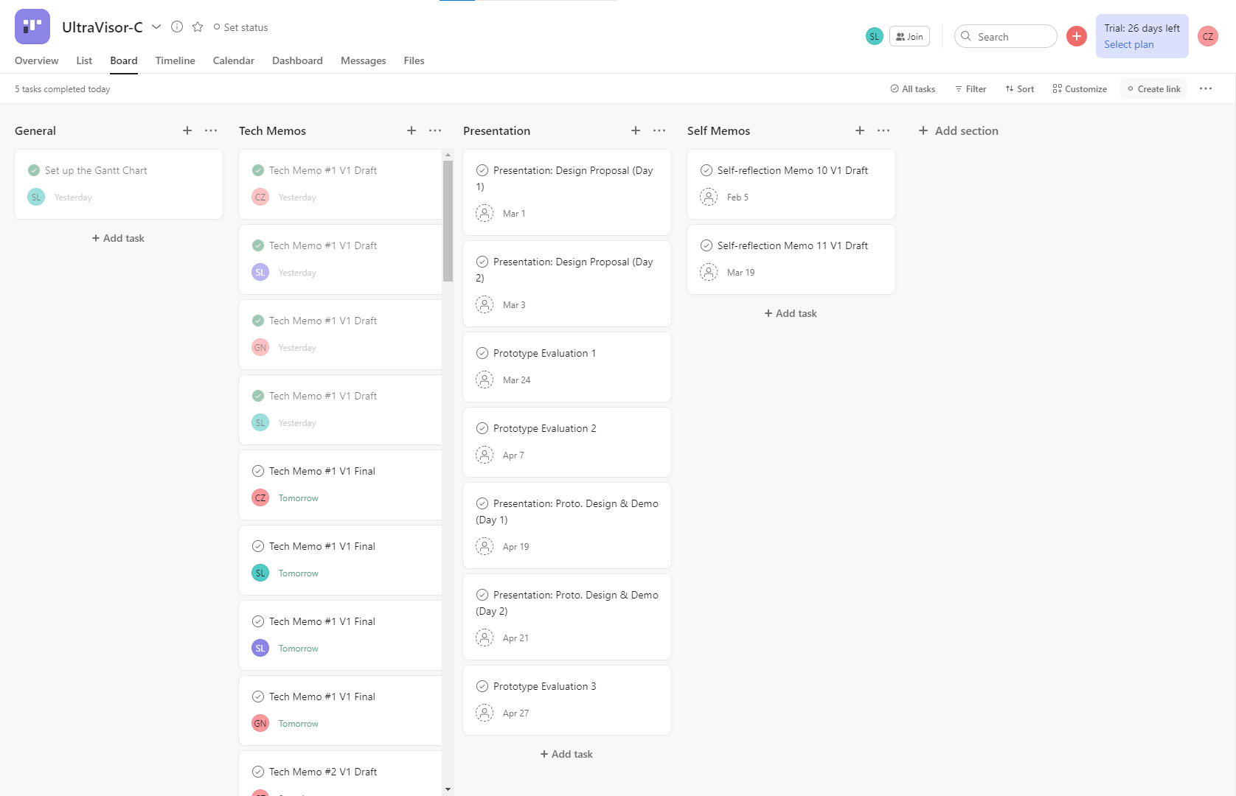

**Figure 1. The UltraVisor-C Team Asana page**

The page where team assignments are created. Divided into 4 categories: General, Tech Memos, Presentation, and Self memos.

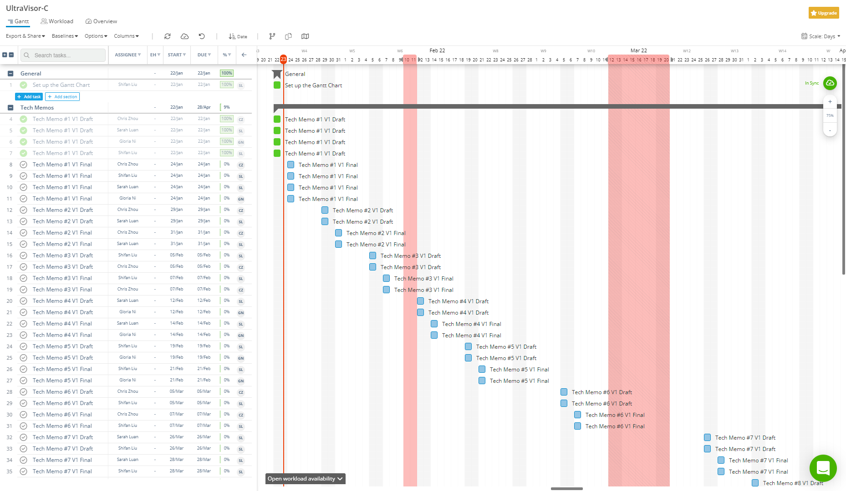

**Figure 2. The UltraVisor-C Team Gantt Chart (Instagantt Page 1)**

The Gantt Chart presented in the Instagantt is connected to Asana and shows all the tasks in a clear timeline.

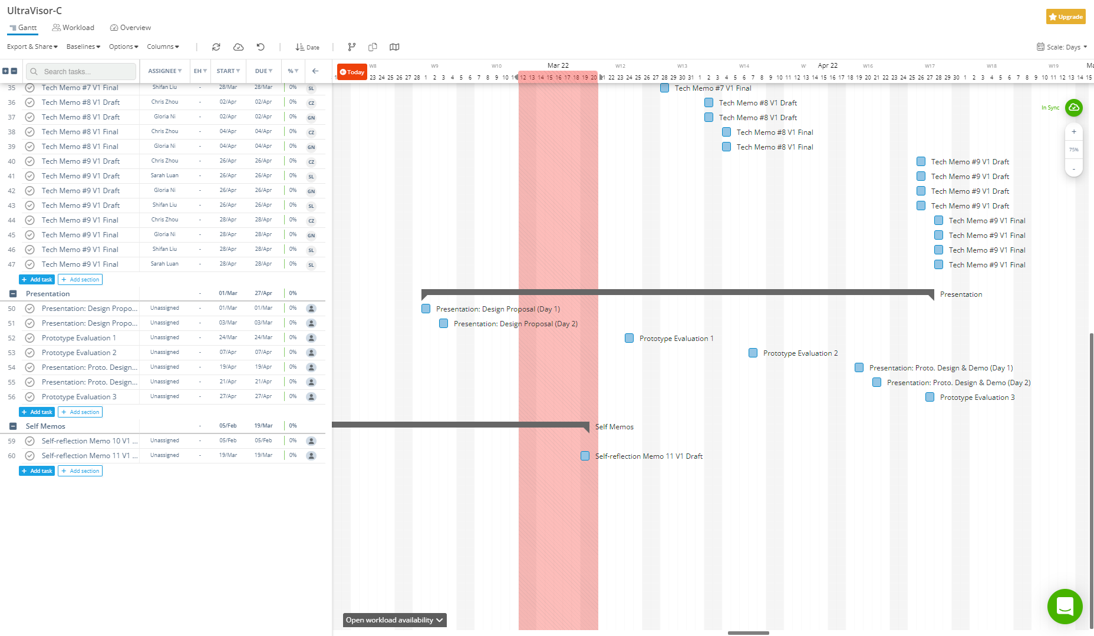

**Figure 3. The UltraVisor-C Team Gantt Chart (Instagantt Page 2)**

The Gantt Chart presented in the Instagantt is connected to Asana and shows all the tasks in a clear timeline.